INDEPENDENT RESEARCH REPORT
Same Scan, Different
E-commerce Outcomes?
Pix, Payment Choice, and Online Participation in a China–Brazil Comparison

Study population | Online consumers in Brazil

Abstract
This study begins with a cross-cultural observation: consumers in both China and Brazil can scan a code to pay, yet the two countries do not produce the same e-commerce experience. It examines how Pix affects online purchasing and when payment convenience is offset by shipping costs, credit constraints, trust, and delivery conditions.
An anonymous online survey conducted from 29 July to 12 August 2026 produced 102 responses. Pix was the primary online payment method for 48.0% of respondents, compared with 40.2% for credit cards. Among 84 online Pix users, 56.0% reported that Pix had enabled at least one purchase they might otherwise not have made. However, when Pix was unavailable, 52.0% would switch payment method, indicating that substitution and additional purchasing coexist.
The China–Brazil comparison shows that China’s advantage does not arise from QR codes alone. It rests on a dense complementary system linking payments, platforms, logistics, ratings, refunds, and consumer credit. Brazil has instead solved payment interoperability through an open, central-bank-led rail. Pix is mature payment infrastructure, but its e-commerce effect remains conditional on services and institutions beyond payment.

1. Introduction

1.1 Research Motivation
The project originated in the author’s experience of living in both China and Brazil. In China, QR payment is usually embedded in the same digital process as product search, checkout, parcel tracking, ratings, refunds, and installments. By December 2025, China had approximately 1.017 billion online-payment users and 936.9 million online shoppers (CNNIC, 2026). Pix presents a similar payment action in Brazil, but operates within a different commercial environment.

1.2 Research Questions
The report asks three questions: Does Pix increase the probability that consumers complete an online purchase? Does its observed effect represent new purchasing or substitution between payment methods? Under what conditions is payment convenience outweighed by shipping, trust, delivery, or credit constraints? The analysis does not assume a direction in advance; it combines consumer responses with official statistics, platform evidence, and prior research.

2. Comparative Context: Different Paths in China and Brazil

2.1 China: Payment Embedded in a Full E-commerce System
China’s e-commerce scale reflects the joint development of several forms of infrastructure. In 2025, online retail sales reached RMB 15.97 trillion; online retail sales of physical goods were approximately RMB 13.1 trillion, or 26.1% of total retail sales; and express-delivery volume reached about 199 billion parcels (National Bureau of Statistics, 2026; National Data Administration, 2026). These measures capture demand, online penetration, and fulfillment capacity, none of which can be explained by payment adoption alone.
The OECD notes that Chinese mobile wallets developed in close connection with major e-commerce and social platforms before expanding across wider consumer settings. This integration can lower search, payment, delivery, review, and refund costs at the same time. China is therefore better described as a coordinated platform–payment–logistics system than as a country with more advanced QR codes (OECD, 2019).
Integration does not distribute benefits evenly. A randomized study of rural e-commerce expansion in China found that consumer gains were concentrated among selected groups, including younger, wealthier, and more remote households, while evidence of higher producer income was limited (Couture et al., 2021). China therefore demonstrates the importance of complementary infrastructure, but not a universal template for welfare gains.

2.2 Brazil: Pix Solved Payment Interoperability First
Pix was launched nationwide on 16 November 2020. Its central infrastructure is organized by the Banco Central do Brasil and supports round-the-clock settlement within seconds across banks and payment institutions (BCB, 2020). On Nuvemshop’s platform in May 2026, Pix accounted for 50.2% of payments, compared with 45.3% for credit cards. Pix should therefore not be described as an early-stage payment method; it is already a mature and frequently used payment rail.
What remains incomplete is the connection between payment and other stages of e-commerce. The OECD identifies complex taxation, long-distance logistics, high last-mile costs, and delivery delays as important constraints on Brazilian digital commerce (OECD, 2020). Pix can shorten payment time and broaden access, but it does not automatically reduce shipping costs, improve fulfillment, or establish seller trust.

2.3 Comparative Finding: Which Frictions Are Reduced Together?
Table 1 compares the functions performed by the two systems rather than treating their market sizes as directly comparable.
Table 1. Institutional comparison of e-commerce and convenient payment
Dimension | China | Brazil
Payment architecture | Mobile wallets are closely linked to large platforms and consumer settings. | Pix is an open, interoperable public payment rail led by the central bank.
Fulfillment conditions | Warehousing, parcel delivery, tracking, and after-sales systems operate at large scale. | Taxation, distance, and last-mile delivery remain material constraints.
Principal strength | Multiple frictions in search, payment, delivery, and refunds can fall together. | Payment access, competition, and participation by consumers without credit cards improve.
Principal risk or gap | Platform concentration, data control, and uneven distribution of benefits. | Credit, trust, delivery, and after-sales services have not advanced at the same pace as payment.
Note. Synthesized from the National Bureau of Statistics of China, National Data Administration, OECD, Banco Central do Brasil, and BIS.
The central difference is not whether consumers scan a code. It is whether payment convenience is combined with product discovery, credit, fulfillment, and consumer protection to reduce transaction costs simultaneously. China provides a case of system coordination; Brazil provides a case of open public payment infrastructure. Each model has distinct strengths and risks.

3. Analytical Framework

3.1 Generalized Transaction Costs
Drawing on Becker’s (1965) treatment of time costs and McFadden’s (1974) framework for consumer choice, the purchase decision can be summarized as follows:
Net purchase benefit = Expected consumption value − Generalized transaction costs
Generalized transaction costs include monetary expenditure such as product price and shipping, the time cost of waiting and returns, fraud and quality risk, and friction in the payment process. Credit and installments may relax current budget constraints. Pix directly reduces payment steps and settlement time and may lower the effective price through discounts, but it does not remove logistics or trust costs.

3.2 Payment Psychology and Substitution
Behavioral research suggests that faster and less salient payments may weaken the “pain of paying” and increase the probability of an immediate purchase (Soman, 2001). Yet if a consumer simply uses a credit card when Pix is unavailable, the observed outcome is payment substitution rather than new demand. The questionnaire therefore measures both whether Pix enabled an additional purchase and what respondents would do if a merchant did not accept Pix.

4. Data and Methods

4.1 Why a Consumer Survey Was Used
The unit of analysis is the consumer’s checkout decision. The central variables—usual payment method, response to the absence of Pix, reason for abandoning a cart, and additional purchasing—are therefore most directly observed through consumers. An anonymous online questionnaire also reduces privacy concerns around payment and income questions and makes it possible to reach respondents across regions within a short field period. Official statistics, platform data, and academic research provide external context for interpreting the responses.

4.2 Sample and Measures
The survey was open from 29 July to 12 August 2026 and received 102 responses across Brazil’s five regions and 24 state-level units. Seventy-five respondents held a credit card and 27 did not; 73 purchased online at least once a month. Measures covered primary payment method, intensity and reasons for Pix use, behavior when Pix was unavailable, the most recent reason for cart abandonment, and whether Pix had ever enabled an otherwise unlikely purchase.

5. Results

5.1 Pix and Credit Cards Form a Dual Core
Pix was the primary payment method for 49 respondents (48.0%), while 41 (40.2%) mainly used credit cards; the remaining 12 used boleto or debit cards. Pix is the largest single category, but credit cards remain important because of installments and access to credit.
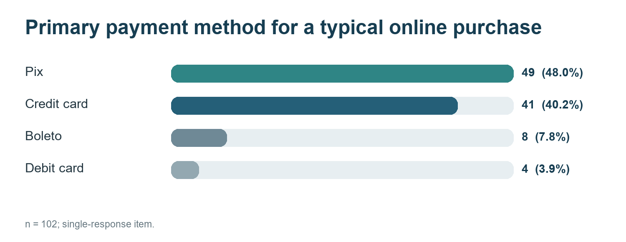
Figure 1. Primary payment method for a typical online purchase (n = 102; single response). Source: Author’s survey.
Pix is attractive for more than speed. Among 84 online Pix users, 81.0% selected speed, 46.4% discounts, 41.7% no fee, and 41.7% avoiding the disclosure of card information. The payment method therefore affects time cost, effective price, and perceived risk.

5.2 Payment Substitution and Additional Purchases Coexist
If a merchant did not accept Pix, 53 respondents (52.0%) would use another payment method, while 49 would switch store, postpone, or abandon the purchase. At the same time, 47 respondents—56.0% of online Pix users—reported that Pix had enabled at least one purchase they might otherwise not have made. Pix is therefore neither a pure credit-card substitute nor evidence that every Pix transaction represents additional demand.
Dependence on Pix was stronger among respondents without a credit card. Of the 27 non-cardholders, 70.4% primarily used Pix, compared with 40.0% of the 75 cardholders—a difference of 30.4 percentage points. This is the clearest structural contrast in the survey and suggests that Pix’s first contribution to financial inclusion is payment access, not merely faster checkout for existing card users.

5.3 Younger Respondents Did Not Show a Stronger Consumption Effect
The survey does not support the intuitive claim that younger consumers are more easily stimulated by a new payment method. Among respondents aged 18–34, 38.1% reported an additional purchase enabled by Pix, compared with 51.9% among those aged 35 or above. Credit-card access, shopping frequency, or discount sensitivity may matter more than age.
Table 2. Self-reported additional purchases enabled by Pix, by age
Age group | Sample | Pix enabled an additional purchase
Under 18 | 8 | 4 (50.0%)
18–34 | 42 | 16 (38.1%)
35 or above | 52 | 27 (51.9%)
Source: Author’s survey.

5.4 Non-payment Costs More Often Drive Cart Abandonment
The most common reason for the latest abandoned purchase was shipping cost (26.5%), followed by product price (17.6%), trust or security (14.7%), delivery time (10.8%), installments or credit limits (9.8%), and returns or refunds (7.8%). Only four respondents (3.9%) selected complicated payment or the absence of Pix.
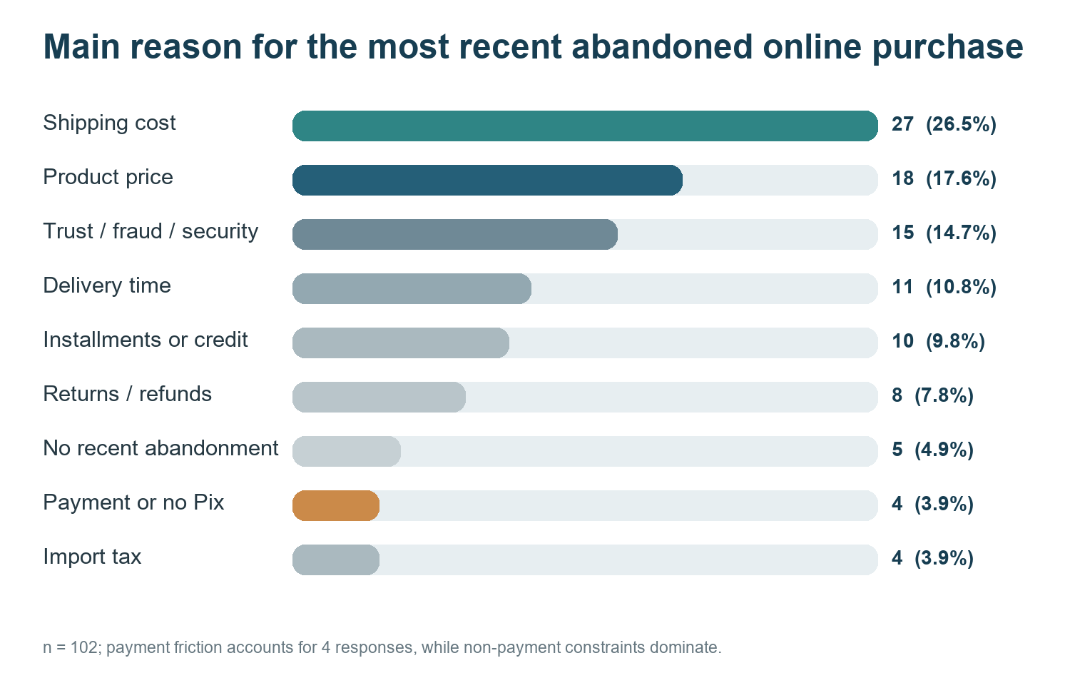
Figure 2. Main reason for the most recent abandoned online purchase (n = 102). Source: Author’s survey.

6. Discussion and Evaluation

6.1 Pix Lowers Entry Barriers but Is Not a Single Growth Engine
Pix affects e-commerce through at least three channels: fewer payment steps and faster settlement; access for consumers without credit cards; and additional immediate purchases encouraged by speed, discounts, or weaker payment salience. However, 46.4% of users also valued Pix discounts. The reported “Pix effect” therefore combines payment convenience with a lower effective price and cannot be attributed entirely to technological speed.
Its marginal effect also varies by product and consumer. Low-priced, standardized goods bought quickly are more likely to respond to payment convenience. High-priced goods requiring installments, complex delivery, or greater trust depend more heavily on credit, logistics, and after-sales support. Payment convenience is one important condition for online trade, but it is not an equally strong stimulus in every setting.

6.2 China Is Evidence of Complementarity, Not a Copy-and-Paste Model
China’s value as a comparator lies in the combined effect of payments, platform governance, logistics, and refunds. If Brazil only expands Pix acceptance, the main gain is payment access. If it also improves shipping transparency, seller identification, delivery reliability, and refund efficiency, payment convenience is more likely to become sustained participation.
China’s integrated model also creates risks of platform concentration, data control, and overconsumption, while rural evidence shows that benefits are heterogeneous (Couture et al., 2021). A more credible direction for Brazil is therefore to retain Pix’s openness and interoperability while building logistics, credit, and consumer-protection services that work across platforms.

6.3 The Next Stage of China–Brazil Cooperation
Brazil’s Ministry of Development, Industry, Trade and Services stated in 2025 that China was Brazil’s largest trading partner and its third-largest source of foreign investment. Cooperation has expanded from merchandise trade into the digital economy and e-commerce, while the 2023 joint statement called for policy exchange, business links, and capacity-building in e-commerce.
Cross-border QR interoperability is more meaningful in this context. After UnionPay and ICBC Brazil advanced QR-code connectivity, UnionPay International launched a pilot that allows eligible China-issued wallets to be used within participating Brazilian acceptance networks. The project is not merely a tourist-payment convenience; it is an initial layer connecting cross-border settlement, merchant services, risk control, and consumer activity.
The larger opportunity is to extend payment connectivity into customs data, parcel tracking, refunds, fraud prevention, and consumer protection. China’s experience in platform operations and large-scale fulfillment can provide a reference, but institutional design must fit Brazil’s open payment architecture, geography, and regulatory environment.

7. Conclusion
The same scanning action does not automatically produce the same e-commerce outcome. Pix clearly lowers payment friction and gives consumers without credit cards a lower-barrier way to pay online. It may also generate some additional purchases through speed, discounts, and payment psychology. Yet payment substitution is common, and shipping, price, trust, delivery, credit, and refunds more often determine whether a transaction is completed.
China strengthens this conclusion because its e-commerce scale reflects several complementary systems reducing transaction costs together, rather than one payment technology. The project began with a personal cross-cultural observation, but the evidence revised the initial emphasis on payment convenience. The more important question is the institutional and service environment in which convenience becomes participation, efficiency, and welfare.

7.1 Limitations
A sample of 102 is small relative to Brazil’s consumer population. The questionnaire was distributed online through personal networks and is therefore a convenience sample that may overrepresent younger, more digitally engaged, or Pix-familiar respondents. Purchase frequency, cart abandonment, and “otherwise unlikely” purchases are self-reported, and the design cannot separately identify the causal effects of speed, discounts, or other mechanisms. Platform transaction data, probability sampling, longitudinal observation, and institutional interviews would provide stronger tests.

Appendix A. Questionnaire
The questionnaire covered age, region, occupation, credit-card ownership, income, online-shopping frequency, primary payment method, intensity and reasons for Pix use, behavior when Pix was unavailable, the most recent reason for cart abandonment, and whether Pix had enabled an additional purchase.
Public questionnaire: Pix e Compras Online: o pagamento é suficiente?

References
China Internet Network Information Center. (2026). The 57th Statistical Report on China’s Internet Development.
National Bureau of Statistics of China. (2026). Statistical Communiqué on the 2025 National Economic and Social Development.
National Data Administration of China. (2026). Digital China Development Report (2025).
OECD. (2019). Unpacking E-commerce: Business Models, Trends and Policies.
Couture, V., Faber, B., Gu, Y., & Liu, L. (2021). Connecting the Countryside via E-Commerce: Evidence from China. American Economic Review: Insights, 3(1), 35–50.
Banco Central do Brasil. (2020). Pix is launched nationwide with 734 institutions.
Banco Central do Brasil. Pix: Official overview and operating features.
Duarte, A., et al. (2022). Central banks, the monetary system and public payment infrastructures: Lessons from Brazil’s Pix. BIS Bulletin No. 52.
Nuvemshop. (2026). Radar do E-commerce D2C, May 2026.
OECD. (2020). Going Digital in Brazil.
Becker, G. S. (1965). A theory of the allocation of time. The Economic Journal, 75(299), 493–517.
McFadden, D. (1974). Conditional logit analysis of qualitative choice behavior.
Soman, D. (2001). Effects of payment mechanism on spending behavior. Journal of Consumer Research, 27(4), 460–474.
Brazilian Ministry of Development, Industry, Trade and Services. (2025). Brazil–China e-commerce opportunities workshop.
Ministry of Foreign Affairs of the People’s Republic of China. (2023). Joint statement on deepening the China–Brazil comprehensive strategic partnership.
China UnionPay. (2025). Progress on China–Brazil cross-border QR-code interoperability.
UnionPay International. (2026). Pilot launch of the China–Brazil inbound QR-code interoperability project.

